Table of Contents
Creating An Account 1
Accessing your account and completing the Registration Form 4
Editing Your Registration Form(s) 12

Creating An Account
- Create an account at: https://members.techbridge.org/forms/new-user-registration/
- Complete all the required fields on the form, agree to the privacy policy and select “submit.”
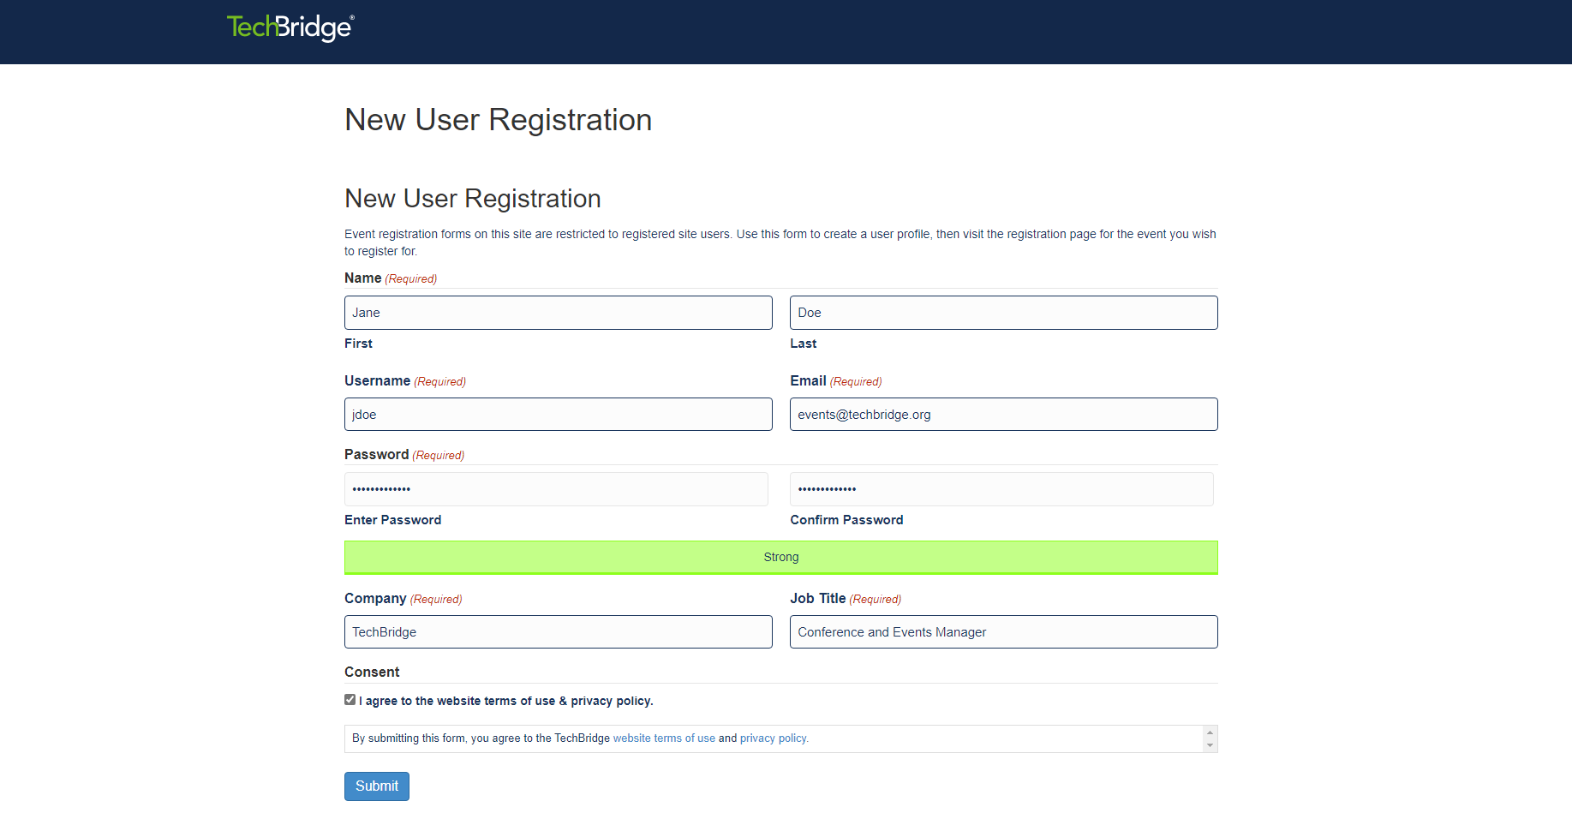
- You will see a screen confirming that your registration has been submitted.

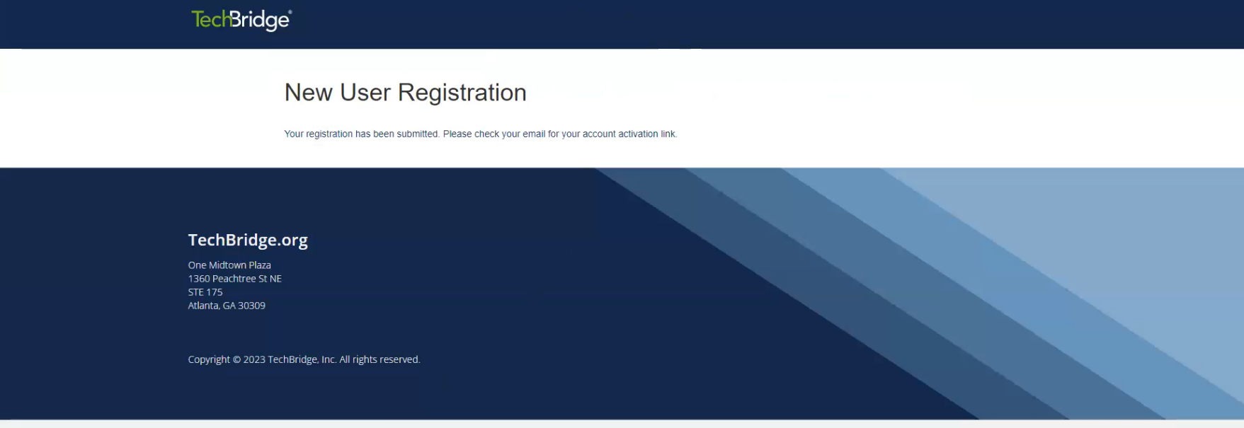
- Check your email for your account activation link. (Note: check your spam/junk folder in case the activation email bypasses your account). Click the link in the email to activate your account.
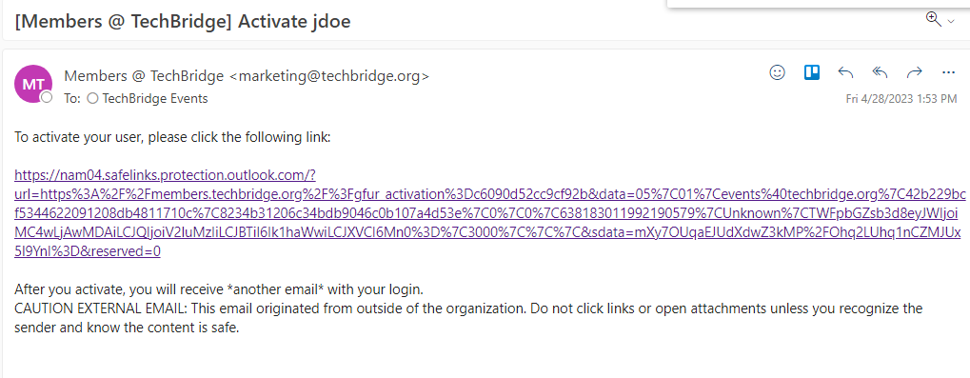
- After clicking the link in the activation email, you will see a screen indicating your account is now active.
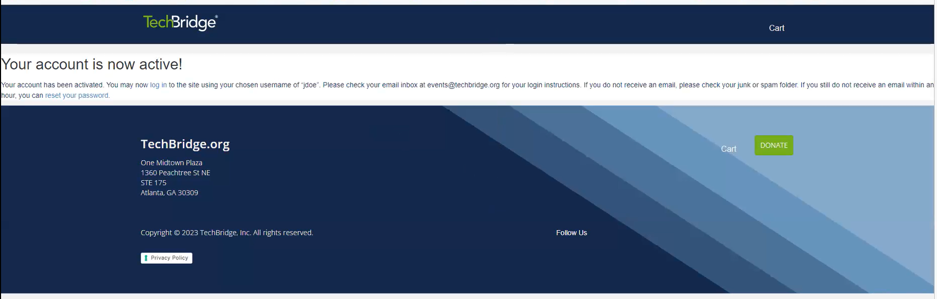

Accessing your account and completing the Registration Form
- After you have created your account, you will receive an email with your login details.
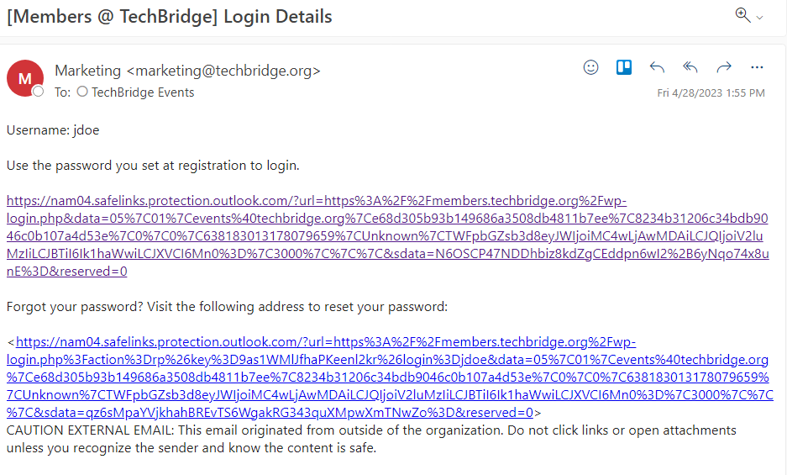
- Click the link in the email to go to the registration log in page. You will use this page to manage your registration(s).
  - You can also access this page directly by going to: https://members.techbridge.org/wp-login.php and logging in using the username or email address and password you created when you created your account.
- Click “view forms” on the left panel.

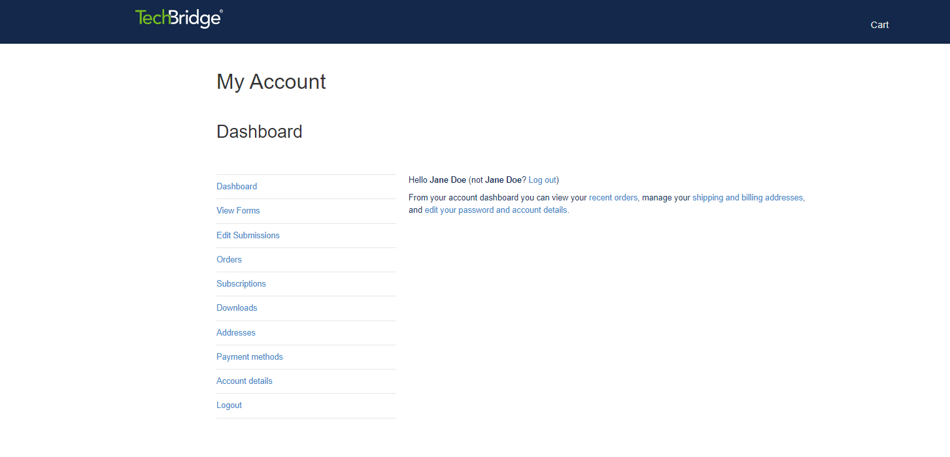
- Select “2023 Digital Ball Registration” from the list of forms.
- Complete the registration form, agree to the consent, and select “submit.”
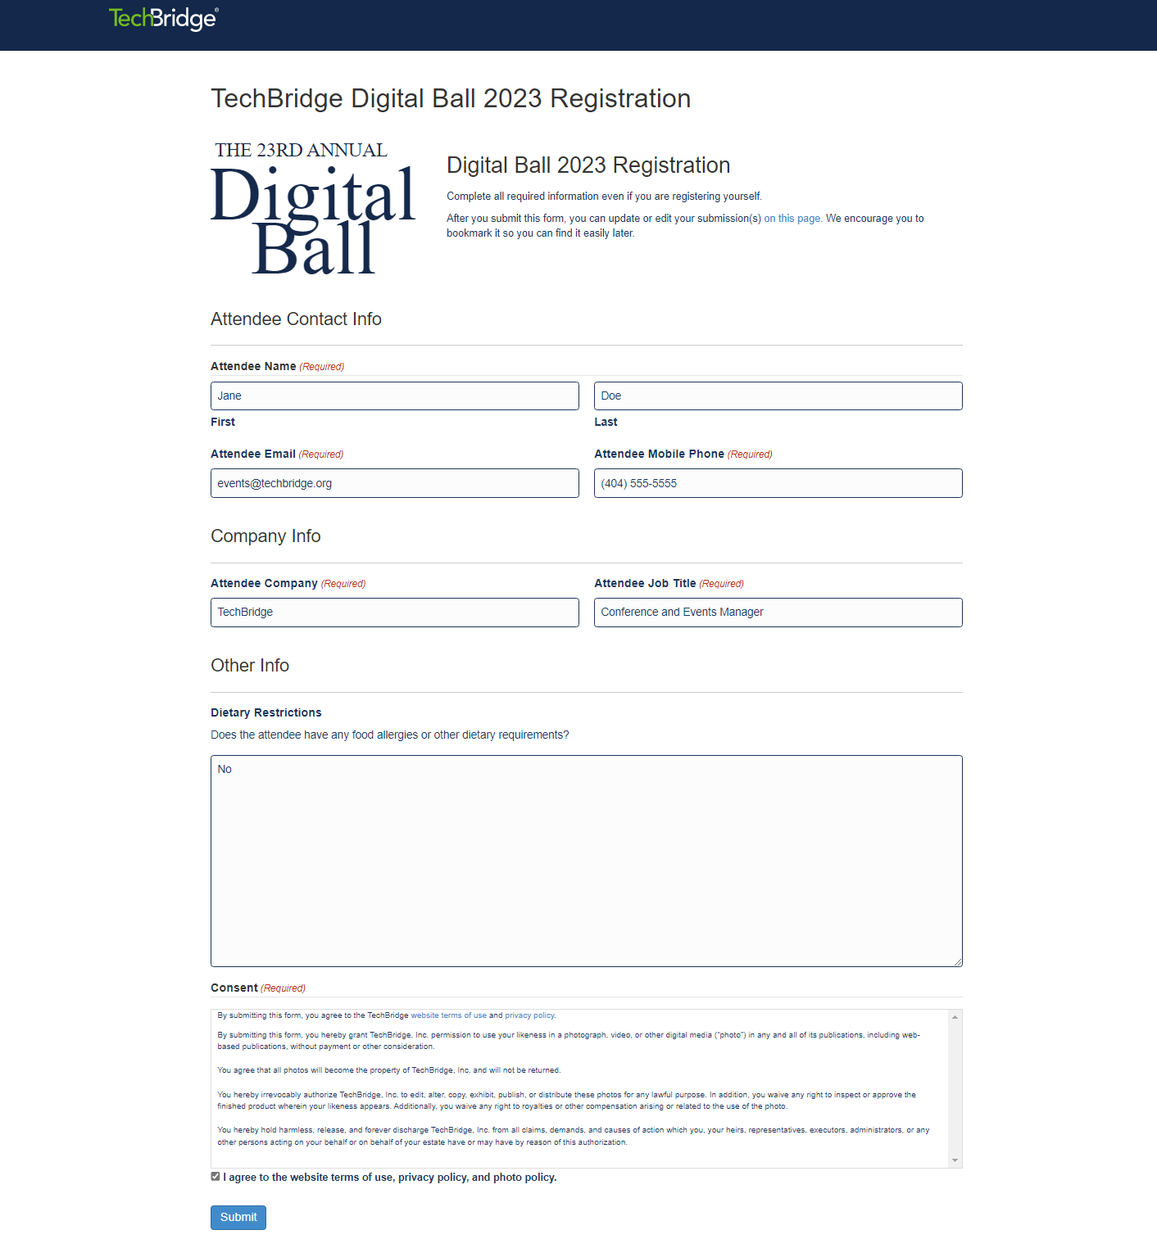
- (Note: You will need to complete a registration form for yourself and any guests you have (if applicable). To register your plus one select “click here” to return to the registration form.
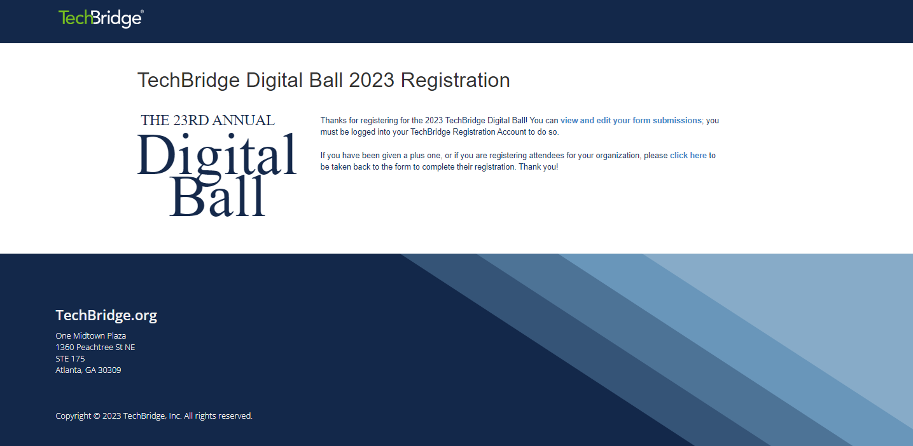
- You will receive a confirmation email once you complete the registration form. If you have registered multiple people, you will receive a confirmation email for each registration.
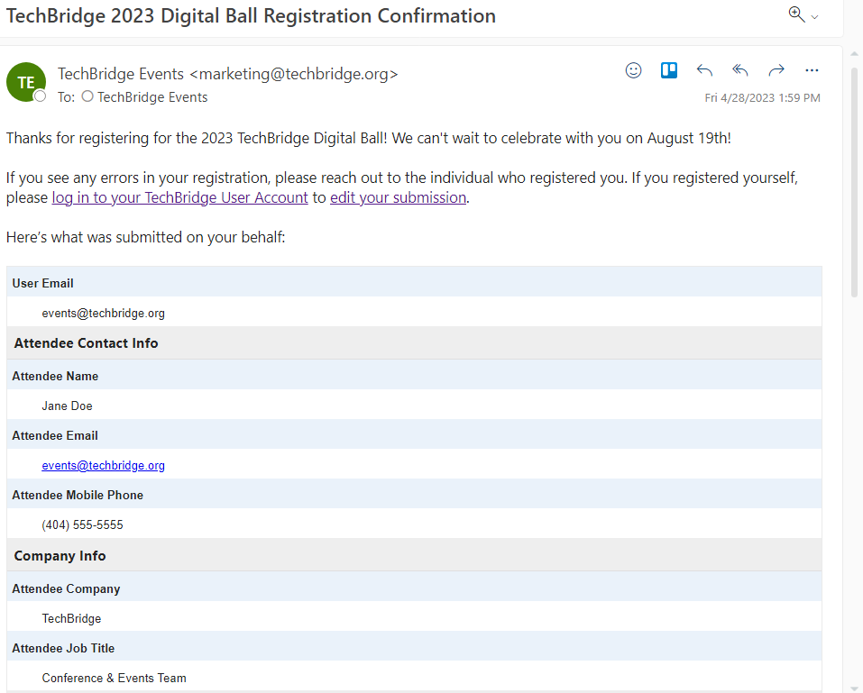
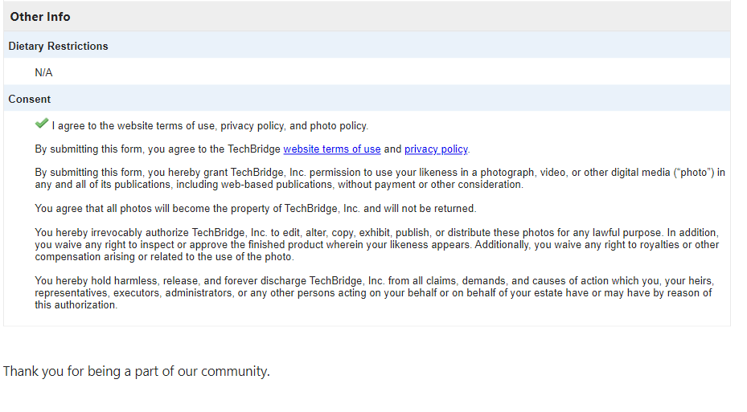

Editing Your Registration Form(s)

If you need to replace someone on your registration list, edit the entry for that person instead of submitting a new registration form. There are two ways you can edit your registration form(s).
Option 1
- If you are already logged in to your account, select "view and edit your form submission.”
- Select “View Details” next to the entry you wish to edit.
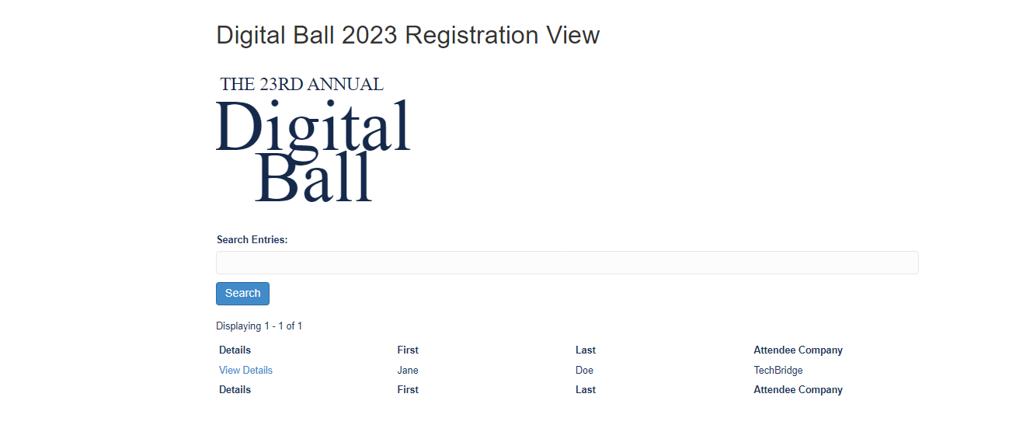
- Select “Edit Form Submission”
- Make the necessary edits to the entry and click “update.”
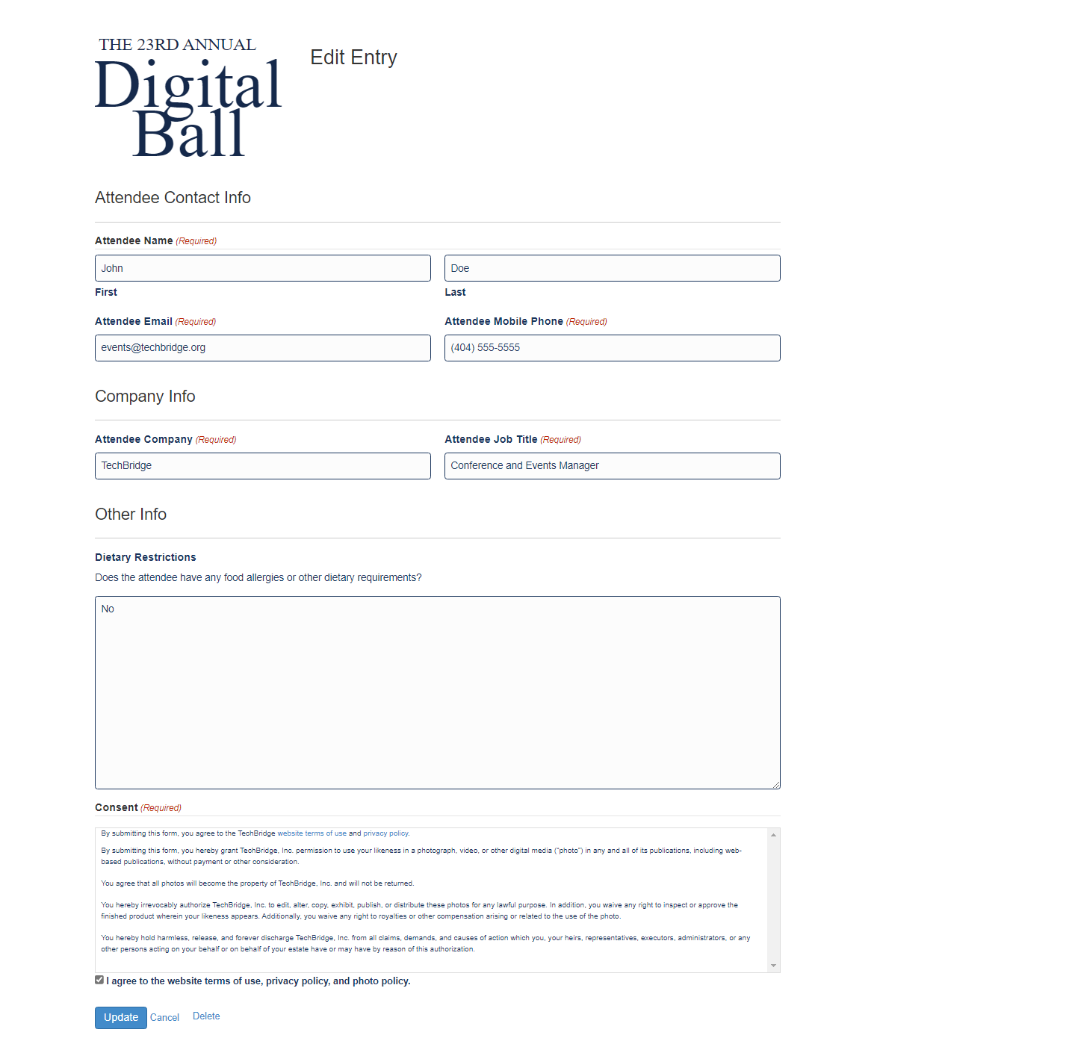
- You will see a confirmation screen once your edits have been saved. Select “Return to Entry” to view your changes.
- Select “go back” to return to the screen with your registrations.
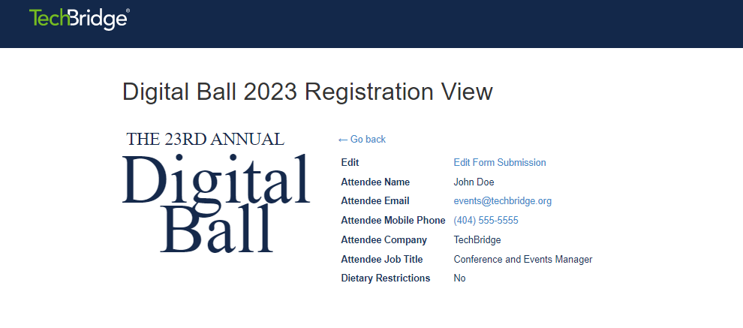
- Repeat steps 2-6 to update additional registrations.

Option 2
- If you are not already logged in to your account, go to https://members.techbridge.org/wp-login.php and log in using your credentials.
- Select “edit submissions”.
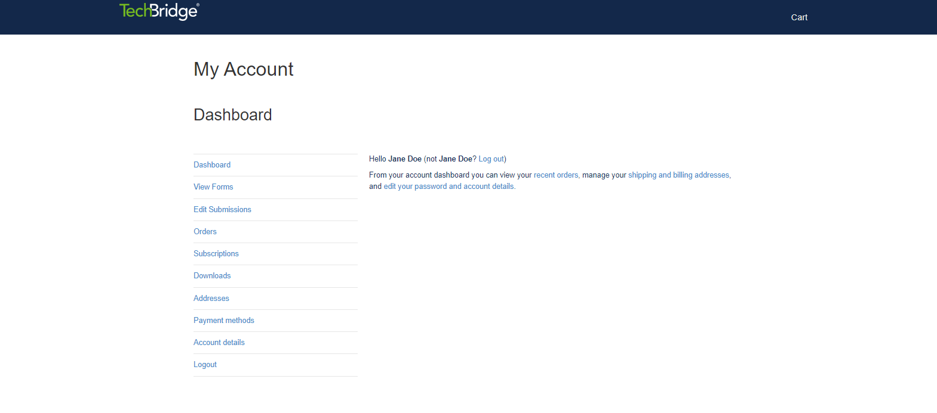
- Select “View or edit your 2023 Digital Ball Registration.”
- Select “View Details” next to the entry you wish to edit.
- Select “Edit Form Submission”
- Make the necessary edits to the entry and click “update.”
- You will see a confirmation screen once your edits have been saved. Select “Return to Entry” to view your changes.
- Select “go back” to return to the screen with your registrations.
- Repeat steps 4-8 to update additional registrations.

